- \Operation\Hot air station\Compressed air (page 1 of 2)
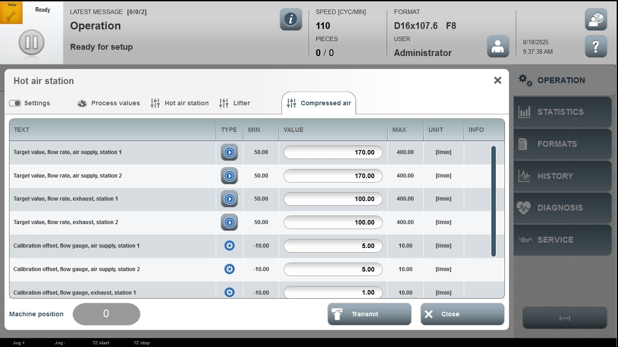

Acceptance criterion | Limits | Pass / Fail: Dev-No. | Date | Initials
Screen matches screenshot | N / A
Target value, flow rate, air  supply station 1 | 50.00 … 400.00
Target value, flow rate, air  supply station 2 | 50.00 … 400.00
Target value, flow rate, exhaust station 1 | 50.00 … 400.00
Target value, flow rate, exhaust station 2 | 50.00 … 400.00
Calibration offset, flow gauge, air supply station 1 | -10.00 … 10.00
Calibration offset, flow gauge, air supply station 2 | -10.00 … 10.00
Calibration offset, flow gauge, exhaust station 1 | -10.00 … 10.00

- \Operation\Hot air station\Compressed air (page 2 of 2)
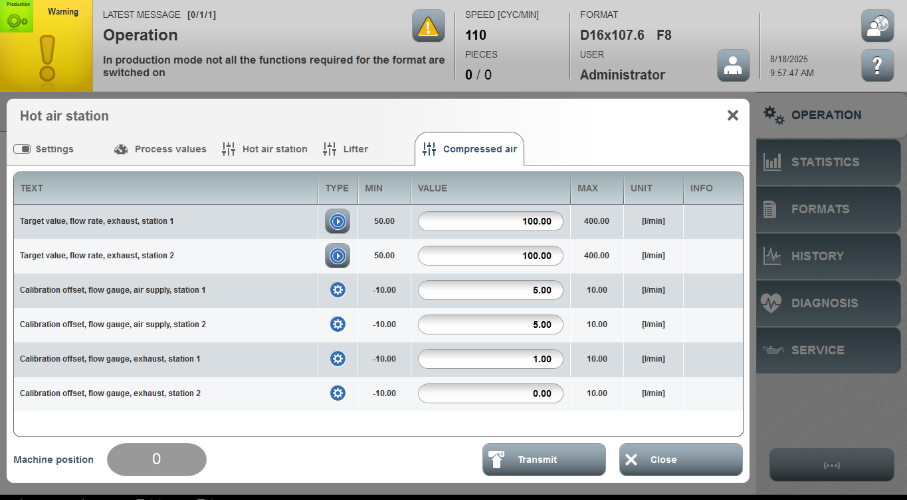

Acceptance criterion | Limits | Pass / Fail: Dev-No. | Date | Initials
Screen matches screenshot | N / A
Calibration offset, flow gauge, exhaust station 2 | -10.00 … 10.00

